January 2025

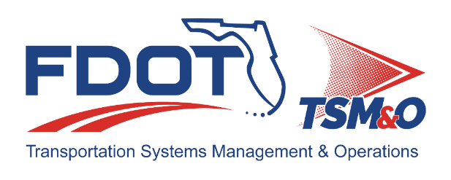
Florida ITS Architecture Support and Maintenance Project
District 5 Update Report
(ARC-IT Version 9.3)

Document Version Control
Author / Action | Submittal Date | Version No.
Natalia Marin / Draft Document Development | January 23, 2025 | A9.3 01/2025
Cliff Heise / QA/QC Review | January 31, 2025 | A9.3 01/2025

Table of Contents
1.0 Introduction 4
2.0 Description of Changes 4

List of Tables
Table 1. Architecture Updates 5
Table 2. Architecture Maintenance Log (District 5 RITSA) 7

Introduction
This Architecture Update Report for the Florida District 5 Regional Intelligent Transportation System (ITS) Architecture (RITSA) identifies the revisions incorporated into the architecture. Revisions made to the District 5 RITSA are documented in this report to support Stakeholder input received through Architecture Change Requests as part of the Florida ITS Architecture Support and Maintenance Project.
The Florida ITS Architecture Support and Maintenance Project included the initial major update of the Statewide ITS Architecture (SITSA) and seven RITSAs. Following the major update phase, periodic updates are executed to maintain the architecture content. The FDOT Architecture Team coordinates with the FDOT Project Manager or designee and each applicable District Transportation Systems Management and Operations (TSM&O) Program Engineer or designee for the RITSAs

Description of Changes
Two maintenance log items were addressed in the update. Table 1 provides descriptions for each change request that was implemented in the architecture update. A log reference number is provided for each change to relate it to the Architecture Maintenance Log that is provided in Appendix A. Each architecture change that is received is added to the maintenance log for tracking and disposition.
Information about stakeholders, elements, and services is provided to summarize the changes. Some architecture components such as interfaces, roles and responsibilities, functional requirements and standards are numerous and can be reviewed on the architecture website or in the Regional Architecture Development for Intelligent Transportation (RAD-IT) software tool to explore the details of each project.

Table 1. Architecture Updates
Change | Log Ref # | Actions Taken / Changes Implemented
Additions to District 5 Architecture Agreements | 187 | - Added:  - Wireless Bridge Agreement (FDOT D5 and Sumter Co)  - OBU License Agreement (FDOT D5 and Seminole Co)  - SODA-TOP OBU License Agreement (FDOT D5, LYNX, and City of Orlando)
FDOT Shortcut System Project: Shortcut System is an ATMS for traffic signals only. District 5 is assessing how the Shortcut system fits into the existing architecture. | 191 | - Added project: FDOT District 5 Shortcut System Implementation  - Added new Element:  - FDOT Shortcut System  - Added Services:  - TM03 Traffic Signal Control (FDOT District 5 Shortcut System).  - TM07 Regional Traffic Management (FDOT District 5 Shortcut System)  - Added User Needs.  - Added Roles and Responsibilities.  - Added Functional Requirements.  - Added Interfaces.  - Added Communications.

Appendix A: Architecture Maintenance Log (District 5 RITSA)
The maintenance log in Table 2 provides the District 5 RITSA maintenance items considerations for the update.

Table 2. Architecture Maintenance Log (District 5 RITSA)
# | Date | Architecture | Source | Contact | Change | Disposition | Recommend Maintenance | Incorporated
187 | 7/31/2024 | D5 RITSA | Change Request Form: FDOT District 5 | Jeremy Dilmore & David Williams / FDOT District 5 | Updates to District 5 Architecture Agreements: New or updated agreements relating to:  1. Wireless Bridge Agreement (FDOT D5 and Sumter Co). Description: License agreement enabling District personnel or its designee to deploy wireless devices on county roadway to facilitate County's connection to FDOT ITS network. The Agreement also enables Sumter County's access to the FDOT ITS network.  2. OBU License Agreement (FDOT D5 and Seminole Co). Description: License agreement enabling District personnel or its designee to deploy OBU devices on Seminole County Fire Department fleet vehicles. Establishes roles and responsibilities for the two parties.  3. SODA-TOP OBU License Agreement (FDOT D5, LYNX, and City of Orlando). Description: License agreement enabling District personnel or its designee to deploy OBU devices on LYNX transit vehicles. Establishes roles and responsibilities for the three parties.  These are new or updated agreements facilitating ITS or CAV deployments with partner local agencies and with vendors. | Add agreement revisions to D5 RITSA | Yes | Yes
191 | 7/30/2024 | D5 RITSA | Email Request | David Williams / FDOT District 5 | FDOT Shortcut System: District 5 is trying to determine how the Shortcut system fits into the existing architecture. | Create project architecture as discussed with D5 staff; Shortcut System is an ATMS for traffic signals only; owned by FDOT | Yes | Yes

